**MATH2059 Numerical Methods**

**Homework 3**

**Question 1. (Optimization)**

Employ the following methods in MATLAB to find the maximum of

$$f\left(x\right)=4x-1.8x^{2}+1.2x^{3}-0.3x^{4}$$

1. Using golden-section search ($x_{l}=-2,x_{u}=4,ε_{s}=1\%$).
2. Using Parabolic interpolation ($x_{1}=1.75, x_{2}=2,x_{3}=2.5, iterations=5$)

(True values are: maximum f(x) = 5.8853 at x = 2.3264)

**Question 2 (optimization):** Develop a single script in MATLAB to (a) generate contour and mesh subplots of the following temperature field. (b) determine the minimum with fminsearch.

$T\left(x,y\right)=2x^{2}+3y^{2}-4xy-y-3$ x

(True values are: val = -5.1250 at (x,y) = (2.75,2))

**Question 3 (Linear Equations)** Solve this problem using a calculator only

Given the equations

$$2x_{1}-6x_{2}-x_{3}=-38$$

$-3x_{1}-x_{2}+7x_{3}=-34$

$$-8x_{1}+x_{2}-2x_{3}=-20$$

1. Solve by Gaussian elimination with partial pivoting. As part of the computation, use diagonal elements to calculate the determinant. Show all steps of the computation.
2. Substitute your results into the original equations to check your answers.

**Question 4 (Linear systems):**

Solve the following set of equations with LU factorization with pivoting:

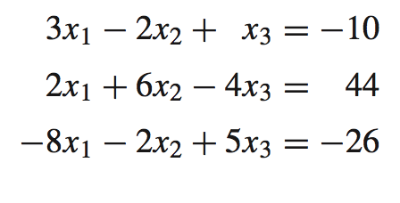

**Question 5 (Linear systems)**

1. Determine the matrix inverse and condition number for the following matrix (use MATLAB)
$$\left[\begin{matrix}1 & 2 & 3 \\ 4 & 5 & 6 \\ 7 & 8 & 9\end{matrix}\right]$$

2. Repeat (a) but change $a_{33}$ to 9.1

**Question 6 (Linear systems- Gauss Seidel)**

Use the Gauss-Seidel method in MATLAB to solve the following system until the percent relative error falls below 5%.

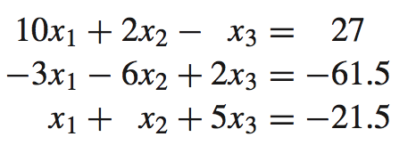

**How to Submit Your Homework:**

1. Each student should submit his/her own homework. You can discuss the questions with your friends, but you must write your own code. Group work is not allowed.
2. Write a detailed report, which includes explanations about each part in each question. Explain how your scripts and functions work, i.e., which parts of your functions/scripts accomplish which task and how it is accomplished. Include the outputs of your functions to your report. You can save a figure as a *.jpg image file using “File —> Save as” in the Figure window. Then, you can include the jpg image to your Word document.
3. Don’t forget to put detailed comments into your functions/scripts to explain what your code is doing. Also indicate the inputs and outputs in the comment section. (% sign is used to put comments in MATLAB)
4. Combine your report and MATLAB codes into a single file. Plots should go into the report. Name your zip file as “name_surname_studentnumber_hw_no.zip”. For example, a student whose name is Ayşe Çalışkan and student number is 1234567 will name her file as: “ayse_caliskan_1234567_hw1.zip” for the first homework. Also, write your name, surname and student number as comments at the beginning of your codes.
5. Submit your HW via Google classroom.